**Press release**

**Embargo: January 21st 2019**

**Scientific title:** The persistence of carbon in the African forest understory

**Journal:** Nature Plants, Volume 5, Issue 2 (published online January 21st 2019)

**DOI:** 10.1038/s41477-018-0316-5

**---------------**

**A small tree is not always a young tree**

**Small mysterious trees are among the oldest in the Congolese rainforest**

**Forest giants have long been considered the oldest trees in tropical forests. Research now shows that small trees can also be very old, and can even grow older than the big ones. Scientists associated with the Royal Museum for Central Africa [today] published this novel finding in the leading journal *Nature Plants*. A colonial map led the researchers to trace many small trees that had barely grown since the end of the Second World War. The discovery that small trees can live longer, and therefore hold on to longer-term carbon, has important consequences for forest policy in the tropics.**

Scientists from the RMCA, the Congolese Institute for Agricultural Research and an international consortium of research institutions made the surprising conclusion that **some small trees** in the Luki reserve, in the southwest of Congo, **are much older than they look**. They hardly appear to grow and almost stand still in time.

***With treasure map and metal detector***

To study the growth rate of the trees, the scientists measured growth ring widths on wood samples taken with a hollow drill. A unique aspect is that the growth speed of the trees could be measured with great precision, thanks to the metal identification tags that colonial scientists attached to some 6,000 trees in the reserve 70 years ago. The scars that were left by the nails used for tagging, are now a benchmark in the wood precisely indicating the year 1948. Until recently, the Luki research area had been 'forgotten'. The tags and nails remained in the forest, and were now 'rediscovered' by the RMCA research team. Armed with a colonial 'treasure map' the researchers could find the numbered trees. With a metal detector, they tracked nails that sometimes grew up to 20 cm deep in the wood. It became clear that many small trees grow at an extremely slow pace, and that they can therefore reach a very high age.

***Tens of thousands of trees***

The unique data from the Congolese rainforest were compared with 'classic' growth measurements from the ‘African Tropical Rainforest Observation Network’ (www.afritron.org), led by the University of Leeds and with rainforest research plots from across 11 Central African countries. Growth was determined on the basis of successive diameter measurements since 1970, for tens of thousands of trees. These confirmed that variation in growth rate is the key to a fuller understanding of how trees grow and how old they grow. **"A small tree is not always a young tree"**, Bhély Angoboy Ilondea of the RMCA explains. **"We found that a tree with a diameter of 10 cm can easily be 300 years old, while trees ten times larger may be half the age"**.

***May they live for evermore***

Tropical forests are essential to regulate the climate by storing excess CO2 from the atmosphere. They contain half of the biomass carbon on earth. The new knowledge about the age of small trees in tropical forests matters for tropical forest policy aimed at carbon storage. A small tree contains little carbon, but they live long and are very numerous. Large trees are rarer and have faster life-cycles, but each contains more carbon. “**Our work shows that both the large and the small trees contribute to ensure carbon is locked up. This is an important reminder to scientists and managers to focus on longevity as well as size. “One tends to see only the big trees in the forest, but appearances are deceptive**”, explains Bhély.

**---------------**

The new AfricaMuseum opened its doors on 9 December 2018. Sustainable forestry in Central Africa is illustrated in the zones dealing with biodiversity and the "resource paradox". The RMCA manages the World’s most important collection of African wood samples, with more than 80,000 specimens belonging to 13,000 different species. This collection is the result of more than 100 years of fieldwork and offers unique study material for a wide series of contemporary projects focused on forest conservation, responsible management and sustainability.

Press contact: KMMA/MRAC, Leuvensesteenweg 13, 3080 Tervuren

Wannes Hubau, 0032 485445984, [wannes.hubau@africamuseum.be,whubau@gmail.com](mailto:wannes.hubau@africamuseum.be,whubau@gmail.com)

Tom De Mil, [tom.de.mil@africamuseum.be](mailto:tom.de.mil@africamuseum.be)

Hans Beeckman, 0032 27695611,[hans.beeckman@africamuseum.be](mailto:hans.beeckman@africamuseum.be)

Bhély Angoboy Ilondea, [bhely.angoboy@gmail.com](mailto:bhely.angoboy@gmail.com)

Main figure :

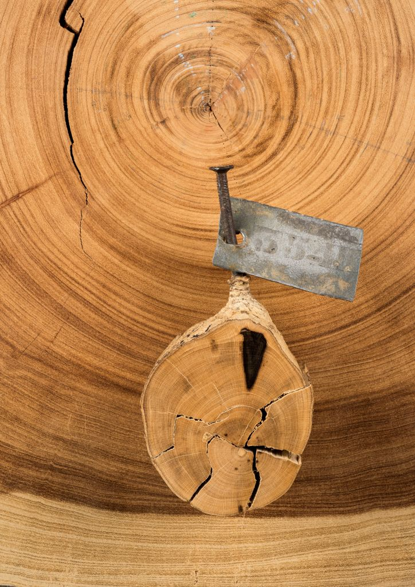

**Keeping up appearances: the small tree is more than 100 years older than the big tree.** The small disk belonged to the trunk of an African tree with a diameter of only 7 cm, but with an age of no less than 329 years. The big disc underneath belonged to the trunk of a tree in the crown layer of the same forest. This large tree reached an age of (only) 203 years, and is therefore more than a century younger. Scientists of the RMCA were able to trace the growth speed and the age of the small tree in this photo with precision thanks to the scars of the nail that was knocked into the trunk to attach the tag in 1948. The zone between the black discoloration and the bark is only a few millimeters wide, but the tree took 70 years to form these growth rings. © RMCA Jo Van de Vijver.

Extra images

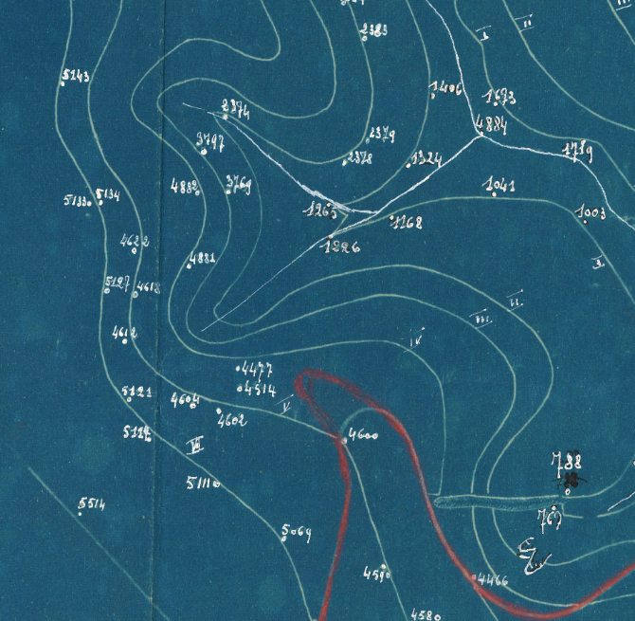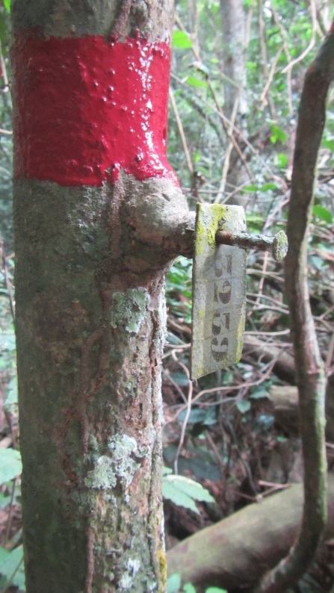

A colonial “treasure map” allowed the researchers to trace trees with number tags that were attached with nails in the 1940s. Some trees have hardly grown over a period of 70 years. © INERA Tom De Mil & Bhély Angoboy Ilondea